DSS II Project Deliverables

Summary:
- Backend API that implements the endpoints, DTOs, validation and HTTP semantics described in this document.
- Database persistence (SQL Server or PostgreSQL recommended).
- Swagger/OpenAPI documentation.
- Dockerfile + docker-compose for the backend (and DB).
- A Word document report describing: how to run locally, DB setup/migrations, screenshotsof Swagger and sample requests/responses, and screenshots of DB tables.

Backend API:

The backend API has already been given via the link to the github repository. For reference, here it is again:
https://github.com/enzo852/DSS-II-project?authuser=0

Database Persistence:

The data stays saved even when the app is turned off: when I create a todo, it gets saved to PostgreSQL and if I restart the app, the todo is still there. Why:
- I’m using PostgreSQL as the database
- EF Core saves all data to actual tables
- The Docker volume in docker-compose.yml ensures data survives container restarts

Swagger/OpenAPI documentation:

Here is the documentation for my project: http://localhost:3087/scalar/v1

And here is the JSON format (in case): http://localhost:3087/openapi/v1.json

(PS: You need to start the app locally with the command “dotnet run” in the backend)

Dockerfile + docker-compose for the backend (and DB)

All files regarding the dockerfile (dockerfile + docker-compose.yml) are already in the github repository. For the instructions on how to run docker, it will be in the report part.

Report Part:

How to run locally:
1. Install .NET 10 SDK
2. Install PostgreSQL 16
3. Create a database named "tododb" in pgAdmin
4. Navigate to dss2-backend/TodoApi/
5. Run: dotnet run
6. API is available at http://localhost:3087

How to run Docker:
1. Install Docker Desktop
2. Open a terminal at the project root
3. Run: docker compose up --build
4. Frontend: http://localhost:3000
5. API: http://localhost:3087

DB setups and Migrations:
Migrations are handled automatically by EF Core.
Locally: dotnet ef database update
Docker: migrations run automatically on startup

Screenshots:
Swaggers:
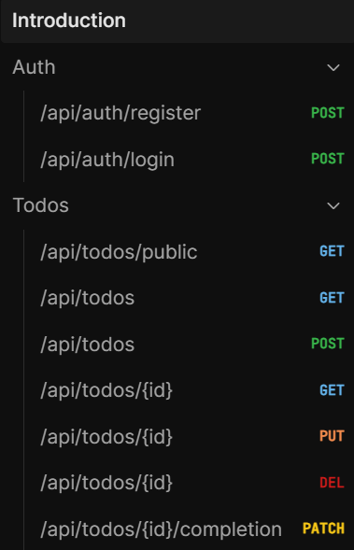
Sample requests/responses:

DB Tables:
Todo Items:
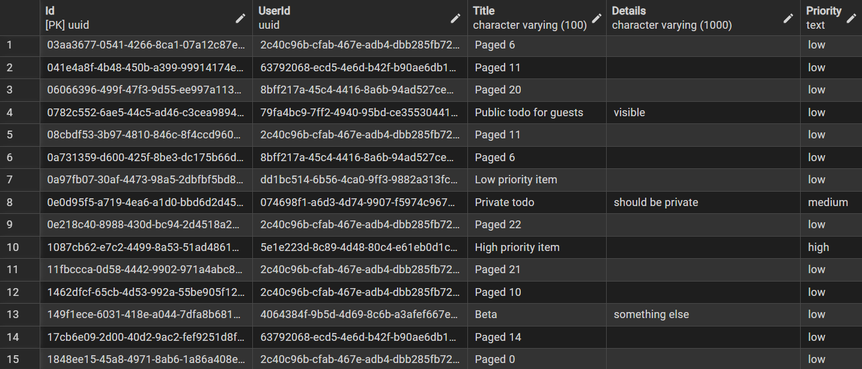
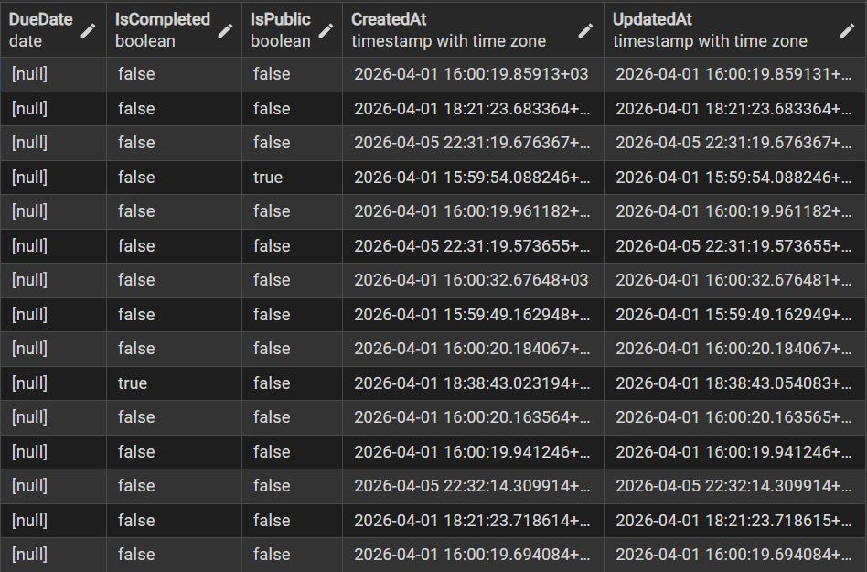

Users:
